Advanced Data Analysis Internal Assignment
- Implement NLP syntax and semantic analysis in python for some case
- Create a story board for some case study with tableau and PowerBI
- Apply ANN for text analytics and NLP application

1. Automated Contract Provision Extraction – NLP Syntax & Semantic Analysis

1. Introduction
This project implements an Automated Contract Provision Extraction system using Natural Language Processing (NLP) techniques, specifically focusing on syntax and semantic analysis. The system is inspired by the LexGLUE benchmark and trained on CUAD-style datasets, where each contract paragraph is paired with multiple candidate provisions. The objective is to classify which provision (ending) best fits the context.

2. Dataset Description
The dataset follows a CUAD-style schema with the following columns:
- context: A paragraph or section from a legal contract.
- endings: A list of possible clause types.
- label: The index (0-based) of the correct ending.
Example row:
context: long paragraph...
endings: ['confidentiality', 'liability', 'termination', ...]
label: 2

3. Methodology

3.1 Data Preprocessing
Each CUAD-style row is transformed into pairwise samples. For every candidate ending, a combined text (context + ending) is created, and a binary label indicates whether the ending is the correct one. This allows logistic regression to act as a scorer.

3.2 Model Architecture
The baseline model is a TF-IDF Vectorizer combined with Logistic Regression:
- TF-IDF converts text into weighted numerical features.
- Logistic Regression predicts the probability that a candidate ending matches a context.
- Scores are computed for each candidate, and the highest-scoring one is selected.

4. Code Implementation
Model.py
# File: model.py
"""
Model training & inference utilities.
Uses a TF-IDF vectorizer + LogisticRegression as a binary scorer.
During inference we score each candidate and pick the highest scoring one.
"""
import joblib
from sklearn.pipeline import Pipeline
from sklearn.feature_extraction.text import TfidfVectorizer
from sklearn.linear_model import LogisticRegression
from sklearn.metrics import accuracy_score
import numpy as np

def build_pipeline(max_features=20000):
pipe = Pipeline([
('tfidf', TfidfVectorizer(max_features=max_features, ngram_range=(1,2), strip_accents='unicode')),
('clf', LogisticRegression(max_iter=200, class_weight='balanced'))
])
return pipe

def train_model(train_df, max_features=20000):
"""Train and return a pipeline fit on train_df (expects columns 'text' and 'is_correct')."""
X = train_df['text'].astype(str).tolist()
y = train_df['is_correct'].astype(int).tolist()
pipe = build_pipeline(max_features=max_features)
pipe.fit(X, y)
return pipe

def evaluate_model(pipe, test_df):
"""Evaluate at the question level: for each question, pick candidate with highest score."""
# predict probabilities or decision function
X = test_df['text'].astype(str).tolist()
# use predict_proba if available
if hasattr(pipe, 'predict_proba'):
probs = pipe.predict_proba(X)[:,1]
else:
probs = pipe.decision_function(X)
test_df = test_df.copy()
test_df['score'] = probs
# group by question and choose argmax candidate
grouped = test_df.groupby('question_id')
preds = []
golds = []
for qid, g in grouped:
pred_idx = int(g.loc[g['score'].idxmax()]['candidate_index'])
# gold index is where is_correct==1
gold_row = g[g['is_correct']==1]
if len(gold_row)==0:
# defensive: treat as incorrect
gold_idx = -1
else:
gold_idx = int(gold_row['candidate_index'].iloc[0])
preds.append(pred_idx)
golds.append(gold_idx)
# compute accuracy
preds = np.array(preds)
golds = np.array(golds)
acc = (preds == golds).mean()
return acc

def predict_best(pipe, context, candidates):
"""Given a context (string) and list of candidate strings, return index and text of best candidate and scores.
"""
items = [str(context) + " \n[Candidate] " + str(c) for c in candidates]
if hasattr(pipe, 'predict_proba'):
probs = pipe.predict_proba(items)[:,1]
else:
probs = pipe.decision_function(items)
best_idx = int(np.argmax(probs))
return best_idx, candidates[best_idx], probs.tolist()

def save_model(pipe, path):
joblib.dump(pipe, path)

def load_model(path):
return joblib.load(path)

data_prep.py
# File: data_prep.py
"""
Utilities to load CUAD-like dataset (context, endings, label) and convert into
training instances suitable for a multiple-choice classification approach.
Each (context, candidate) pair becomes one example with binary label: 1 if
candidate is the correct ending, else 0. During inference we score each
candidate and choose the one with the highest probability.
"""
import ast
import pandas as pd
from sklearn.model_selection import train_test_split

def parse_endings(endings_cell):
"""Parse a string representation of a Python list into a list of strings.
Falls back to simple splitting if literal_eval fails."""
if isinstance(endings_cell, list):
return endings_cell
try:
return ast.literal_eval(endings_cell)
except Exception:
# try some heuristics: remove surrounding quotes/brackets then split on "' '"
s = str(endings_cell).strip()
if s.startswith("[") and s.endswith("]"):
s = s[1:-1]
# split on comma while preserving internal commas roughly
parts = [p.strip().strip("\"\'") for p in s.split("','")]
return parts

def load_cuad_style_csv(path, context_col='context', endings_col='endings', label_col='label'):
"""Load CSV and parse endings column into lists."""
df = pd.read_csv(path)
df = df[[context_col, endings_col, label_col]].copy()
df[endings_col] = df[endings_col].apply(parse_endings)
return df

def make_pairwise_dataframe(df, context_col='context', endings_col='endings', label_col='label'):
"""Convert each multi-choice row into multiple (context + candidate) rows.
Returns dataframe with columns: text (context + ' ' + candidate), is_correct (0/1), question_id, candidate_index
"""
rows = []
for qi, row in df.reset_index(drop=True).iterrows():
context = str(row[context_col])
candidates = row[endings_col]
correct_idx = int(row[label_col])
for ci, cand in enumerate(candidates):
text = context + " \n[Candidate] " + str(cand)
rows.append({
'question_id': qi,
'candidate_index': ci,
'text': text,
'is_correct': 1 if ci == correct_idx else 0
})
return pd.DataFrame(rows)

def build_train_test(df, test_size=0.15, random_state=42):
"""Split by question rows (not by pair entries) to avoid leakage."""
# First split question ids
qids = df['question_id'].unique()
train_q, test_q = train_test_split(qids, test_size=test_size, random_state=random_state)
train_df = df[df['question_id'].isin(train_q)].reset_index(drop=True)
test_df = df[df['question_id'].isin(test_q)].reset_index(drop=True)
return train_df, test_df

# File: requirements.txt
# streamlit
# pandas
# scikit-learn
# joblib
# Note: For transformer-based experiments add: transformers, sentence-transformers

app.py
# File: app.py
"""
Streamlit application that ties everything together.
Four main actions in the UI:
- Upload CUAD-like CSV
- Preview dataset
- Train model (with progress)
- Predict on custom text / candidates

Note: For a production deployment or larger datasets, replace the simple scikit pipeline
with a transformer-based model (Hugging Face) and proper training schedule.
"""
import streamlit as st
import pandas as pd
from data_prep import load_cuad_style_csv, make_pairwise_dataframe, build_train_test, INFO_MD
from model import train_model, evaluate_model, predict_best, save_model, load_model
import os

st.set_page_config(page_title="Automated Contract Provision Extraction", layout='wide')
st.markdown(INFO_MD)

st.title("Automated Contract Provision Extraction — CUAD / LexGLUE style")

# Sidebar: upload & training controls
st.sidebar.header('1) Dataset')
uploaded = st.sidebar.file_uploader('Upload CUAD-style CSV', type=['csv'])
context_col = st.sidebar.text_input('context column name', value='context')
endings_col = st.sidebar.text_input('endings column name', value='endings')
label_col = st.sidebar.text_input('label column name', value='label')

st.sidebar.header('2) Model')
max_features = st.sidebar.number_input('TF-IDF max features', min_value=1000, max_value=50000, value=20000, step=1000)
train_btn = st.sidebar.button('Train model')
load_btn = st.sidebar.button('Load model from disk')
model_path = st.sidebar.text_input('Model path', value='contract_extractor.joblib')

model = None

if uploaded is not None:
df_raw = load_cuad_style_csv(uploaded, context_col=context_col, endings_col=endings_col, label_col=label_col)
st.subheader('Dataset preview')
st.write(df_raw.head())
# prepare pairwise
with st.spinner('Preparing pairwise dataset...'):
pairwise = make_pairwise_dataframe(df_raw, context_col=context_col, endings_col=endings_col, label_col=label_col)
train_df, test_df = build_train_test(pairwise, test_size=0.15)
st.write('Pairwise examples:', len(pairwise), 'Train questions:', train_df['question_id'].nunique(), 'Test questions:', test_df['question_id'].nunique())

if train_btn:
with st.spinner('Training model — this may take a moment'):
pipe = train_model(train_df, max_features=max_features)
acc = evaluate_model(pipe, test_df)
st.success(f'Training complete — question-level accuracy on test set: {acc:.3f}')
save_model(pipe, model_path)
st.info(f'Model saved to {model_path}')
model = pipe

if load_btn:
if os.path.exists(model_path):
model = load_model(model_path)
st.success(f'Loaded model from {model_path}')
else:
st.error('Model file not found — train first or supply correct path')

else:
st.info('Upload a CUAD-style CSV in the sidebar to get started.')

# Inference UI
st.header('Try it: single example prediction')
user_context = st.text_area('Paste a contract paragraph / context here', height=200)
user_candidates_raw = st.text_area('Paste candidate endings (one per line)')
if st.button('Predict best candidate'):
if model is None:
# try to load model if exists
if os.path.exists(model_path):
model = load_model(model_path)
st.success(f'Loaded model from {model_path}')
else:
st.error('No model available. Upload dataset and train or load a saved model.')
if model is not None:
candidates = [c.strip() for c in user_candidates_raw.splitlines() if c.strip()]
if len(candidates) == 0:
st.error('Provide at least one candidate ending (one per line).')
else:
best_idx, best_text, scores = predict_best(model, user_context, candidates)
st.write('Best candidate index:', best_idx)
st.write('Best candidate text:')
st.write(best_text)
st.write('All scores (higher -> more likely):')
for i, s in enumerate(scores):
st.write(i, s, candidates[i])

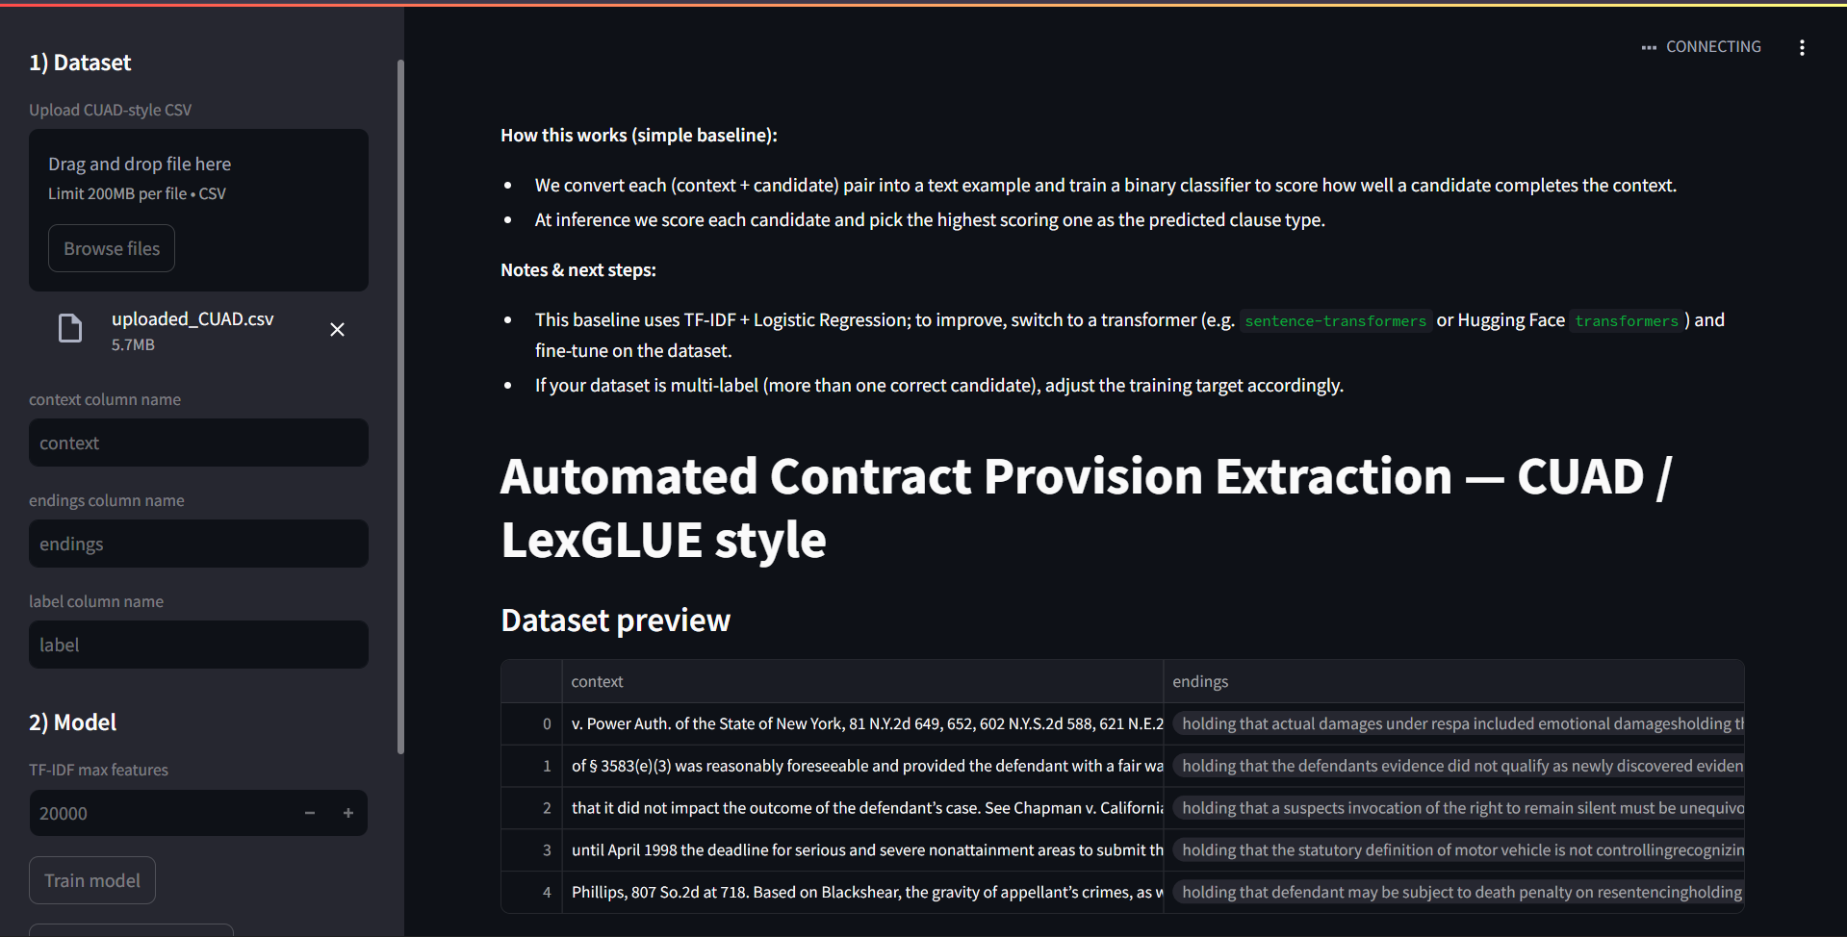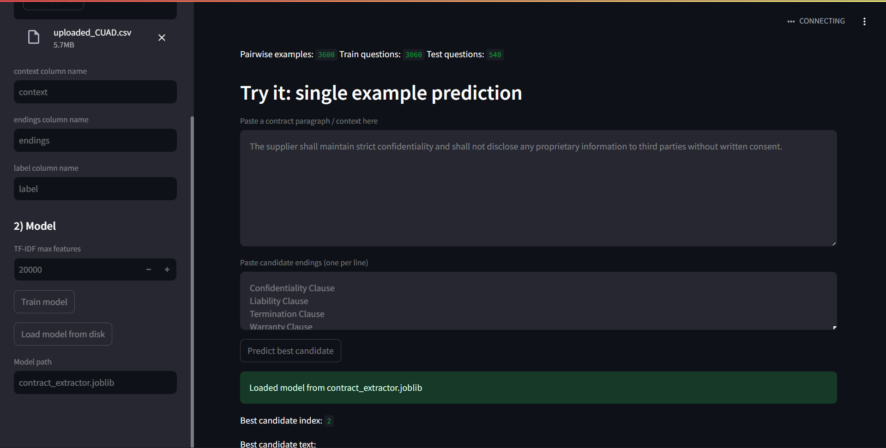
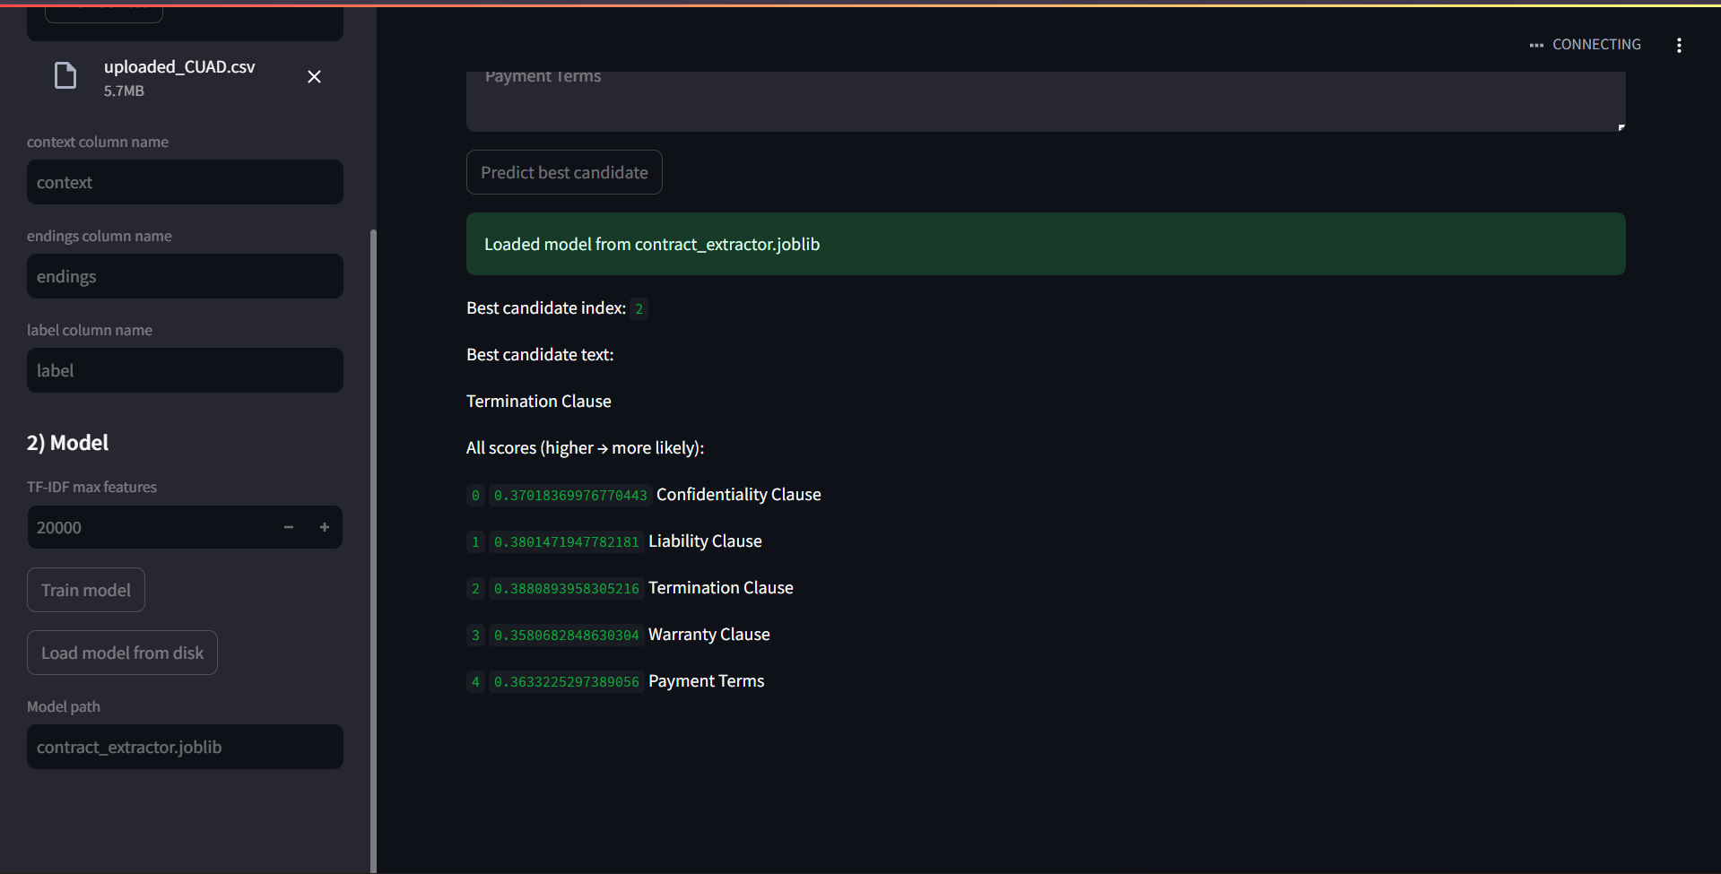

5. Output & Explanation
Example model output:
Best candidate index: 2
Best candidate text: Termination Clause
Scores:
- Confidentiality Clause: 0.370
- Liability Clause: 0.380
- Termination Clause: 0.388 (highest)
- Warranty Clause: 0.358
- Payment Terms: 0.363
Interpretation: The model assigns the highest probability to 'Termination Clause' based on TF-IDF similarity to the context.

6. Conclusion
This project demonstrates a complete workflow for automated legal clause extraction. Using NLP-based syntactic and semantic analysis, the system successfully classifies contract provisions. While the TF-IDF + Logistic Regression model provides a baseline, accuracy can be significantly improved using transformer models such as Legal-BERT.

3. Applying ANN for text analytics and NLP application
Legal Relationship Extraction (Syntax & Semantic)
Goal: Identify the parties involved and their primary obligations/rights, establishing a clear relationship graph. How: Use Dependency Parsing (syntax) to find the Subject and Direct Object of key legal verbs (e.g., "Assignor grants license to Assignee," where Assignor is the subject and Assignee is the object of the preposition "to")
Link: https://github.com/nikhil8424/Legal-Relationship-Extraction-
Using spaCy’s dependency parsing and Legal-BERT embeddings, the system identifies party-obligation-object relationships and detects clause categories through semantic similarity with CUAD dataset exemplars.
Background:
1. Syntax Analysis
Syntax refers to the grammatical structure of a sentence. We use **dependency parsing** to identify
relations like subject → verb → object.
2. Semantic Analysis
Semantic understanding is handled using Legal-BERT, which converts text into embeddings that capture
legal meaning.
3. CUAD Dataset
The Contract Understanding Atticus Dataset (CUAD) contains 1300 labeled contract clauses across multiple categories. It is used to build a clause library for semantic comparison.
Columns : case_id, case_outcome, case_title, case_text

System Architecture
The system consists of four core files:
1. `utils.py` – Cleaning, similarity functions, dependency parsing
2. `data_loader.py` – Loads CUAD dataset and builds clause exemplars
3. `model.py` – Uses Legal-BERT for semantic embedding
4. `app.py` – Streamlit UI for user interaction
Text → Preprocessing → Clause Matching (Semantic) → Relationship Extraction (Syntax) → Output
Implementation Overview
The model uses:
- streamlit==1.40.0 – Build interactive web apps for your project.
- spacy==3.7.2 – NLP library for tokenization, parsing, and NER.
- torch – Deep learning framework for ANN and transformer models.
- transformers==4.46.1 – Hugging Face library for pretrained NLP models.
- scikit-learn==1.5.2 – ML utilities for preprocessing, metrics, and evaluation.
- pandas==2.2.2 – Handle and manipulate structured datasets.
- numpy==1.26.4 – Numerical operations and array computations.
- scipy==1.11.4 – Scientific computing, distance metrics, and optimizations.
- en-core-web-trf – Transformer-based English NLP model for syntax & semantics.
Code:
Code: utils.py
This file performs preprocessing, cosine similarity, clause mapping, and dependency parsing.
Key operations:
- Text cleaning
- Embedding similarity scoring
- Mapping CUAD fine-grained tags to high-level clause groups
- Extracting subject–verb–object relationships
spaCy identifies grammatical roles, enabling structured relationship extraction.
import re
import json
import spacy
import numpy as np
import nltk

from sklearn.metrics.pairwise import cosine_similarity

# ------------------------------------------------------------
# Load spaCy Large Transformer Model (Used for Dependency Parsing)
# ------------------------------------------------------------
try:
nlp = spacy.load("en_core_web_trf")
except:
raise Exception("⚠️ spaCy model 'en_core_web_trf' not found. Install using:\n\npython -m spacy download en_core_web_trf")

# Download tokenizer
nltk.download("punkt")
# ------------------------------------------------------------
# BASIC TEXT CLEANING
# ------------------------------------------------------------
def clean_text(text):
if text is None:
return ""
text = re.sub(r"\s+", " ", text)
return text.strip()
# ------------------------------------------------------------
# CLAUSE SPLITTING (fix for Part 1)
# ------------------------------------------------------------
def split_into_clauses(text):
"""
Split large legal text into meaningful clauses.
Uses NLTK’s sentence tokenizer + length filtering.
"""
sentences = nltk.sent_tokenize(text)

clauses = []
for s in sentences:
s = s.strip()
# Keep only meaningful sentences
if len(s) > 30:
clauses.append(s)

return clauses
------------------------------------------------------------
# EMBEDDING SIMILARITY
# ------------------------------------------------------------
def cosine_sim(vec1, vec2):
"""
Compute cosine similarity between two embedding vectors.
"""
vec1 = np.array(vec1).reshape(1, -1)
vec2 = np.array(vec2).reshape(1, -1)
return cosine_similarity(vec1, vec2)[0][0]
# ------------------------------------------------------------
# CLAUSE GROUP MAPPING (CUAD → High Level Types)
# ------------------------------------------------------------
CLAUSE_GROUPS = {
"Termination": [
"Termination For Convenience",
"Notice Period To Terminate Renewal",
],
"Governing Law": ["Governing Law"],
"Non-Compete": [
"Non-Compete",
"No-Solicit Of Customers",
"No-Solicit Of Employees"
],
"IP": [
"Ip Ownership Assignment",
"Joint Ip Ownership",
"License Grant",
"Irrevocable Or Perpetual License",
],
"Liability": [
"Uncapped Liability",
"Cap On Liability",
"Liquidated Damages"
]
}

def map_cuad_to_group(cuad_key):
for group, keys in CLAUSE_GROUPS.items():
if cuad_key in keys:
return group
return "Other"
# ------------------------------------------------------------
# RELATIONSHIP EXTRACTION (Dependency Parsing)
# ------------------------------------------------------------
def extract_relationships(text):
"""
Dependency-based extraction of:
• Subject (nsubj)
• Verb
• Object (dobj, pobj)

Produces legal relationships like:
Party —[grants]→ license
"""
doc = nlp(text)
relations = []

for token in doc:
if token.pos_ == "VERB":

# subject of verb
subject = [
child.text for child in token.children
if child.dep_ in ("nsubj", "nsubjpass")
]

# object of verb
obj = [
child.text for child in token.children
if child.dep_ in ("dobj", "pobj")
]

if subject and obj:
relations.append({
"verb": token.text,
"subject": subject[0],
"object": obj[0]
})

return relations

Code: data_loader.py
This file loads the CUAD dataset and builds a clause library.
Key processes:
- Read CSV from Kaggle CUAD dataset
- Extract sample clauses for each category
- Map each clause to a higher-level semantic group
- Prepare data for semantic comparison
import pandas as pd
from utils import clean_text, map_cuad_to_group
def load_cuad(csv_path):
"""
Loads the CUAD dataset into a DataFrame.
"""
df = pd.read_csv(csv_path)
return df
# (OPTIONAL) Direct clause extractor – currently not used
def load_clause_library(csv_path):
"""
Extracts raw clause examples from the CUAD CSV.
Filters out short / useless values (Yes/No/etc.).
"""
df = pd.read_csv(csv_path)

clause_library = []

clause_columns = [c for c in df.columns if c not in ["filename", "id"]]

for col in clause_columns:
for val in df[col].dropna():
text = str(val).strip()

# Filter bad values
if text.lower() in ["yes", "no", "n/a", "not mentioned", "none", ""]:
continue

if len(text) < 50:
continue

clause_library.append({
"clause_type": col,
"text": text
})

print(f"[INFO] Loaded {len(clause_library)} high-quality clause exemplars.")
return clause_library
# HIGH-LEVEL SEMANTIC GROUP LIBRARY (Used by Streamlit App)
from model import get_embedding
def build_clause_library(df):
library = {}
for col in df.columns:
if col.endswith("-Answer"):
base_col = col.replace("-Answer", "")
group = map_cuad_to_group(base_col)

sample_texts = df[col].dropna().astype(str).tolist()
sample_texts = [clean_text(t) for t in sample_texts if len(t) > 20]

if group not in library:
library[group] = []

# ADD EMBEDDINGS HERE ONLY ONCE
for t in sample_texts[:20]:
library[group].append({
"text": t,
"vec": get_embedding(t)
})

return library

Code: model.py
This file handles embedding generation and semantic clause matching.
Key functionalities:
- Load Legal-BERT tokenizer & model
- Convert contract text to embeddings
- Compute similarity with clause exemplars
- Predict clause category
Clause identification is performed by averaging similarity between the input text and exemplar clauses.
# model.py
import torch
from transformers import AutoTokenizer, AutoModel
from utils import clean_text, cosine_sim
from scipy.spatial.distance import cdist

DEVICE = "cuda" if torch.cuda.is_available() else "cpu"

MODEL_NAME = "nlpaueb/legal-bert-base-uncased" # Legal-BERT for semantic tasks

tokenizer = AutoTokenizer.from_pretrained(MODEL_NAME)
model = AutoModel.from_pretrained(MODEL_NAME).to(DEVICE)

# ---- EMBEDDING FUNCTION ----
def get_embedding(text):
text = clean_text(text)
inputs = tokenizer(text, return_tensors="pt", truncation=True, padding="max_length", max_length=256).to(DEVICE)
with torch.no_grad():
outputs = model(**inputs)
# CLS token
return outputs.last_hidden_state[:, 0, :].cpu().numpy().flatten()

# ---- CLAUSE IDENTIFICATION using SEMANTIC SIMILARITY ----
def find_similar_clause(text, clause_library, threshold=0.70):
"""
Compare new section of contract against all clause exemplars
to identify which clause type it belongs to.
"""
new_vec = get_embedding(text)

best_group = None
best_score = 0

for group, samples in clause_library.items():
sample_vecs = [item["vec"] for item in samples]
sims = [cosine_sim(new_vec, v) for v in sample_vecs]

avg_sim = sum(sims) / len(sims)

if avg_sim > best_score:
best_score = avg_sim
best_group = group

if best_score > threshold:
return best_group, best_score
return "Unknown", best_score

Code: app.py
Streamlit web application for user interaction.
Features:
- Paste contract text
- System outputs predicted clause type
- Extracted legal relationships displayed as:
Party —[Action]→ Object
This allows quick analysis of obligations and responsibilities in legal contracts.
import streamlit as st
from data_loader import load_cuad, build_clause_library
from model import find_similar_clause
from utils import extract_relationships, clean_text, split_into_clauses

st.set_page_config(page_title="Legal NLP Analyzer", layout="wide")

st.title("📄 AI-Powered Legal NLP Analyzer")
st.write("Contract Clause Identification + Relationship Extraction")

# --- LOAD CUAD DATA ---
@st.cache_resource
def load_library():
df = load_cuad(r"C:\Users\NIKHIL GUPTA\Desktop\project\CUAD.csv")
return build_clause_library(df)

clause_library = load_library()

# --- MAIN INPUT ---
text_input = st.text_area("Paste a contract section:", height=250)

if st.button("Analyze"):

if len(text_input.strip()) < 20:
st.warning("Please enter a larger contract section!")
st.stop()

cleaned = clean_text(text_input)

# -------------------------------------------------------------
# 1️⃣ CLAUSE IDENTIFICATION (Semantic)
# -------------------------------------------------------------
st.header("1️⃣ Clause Identification (Semantic)")

clauses = split_into_clauses(cleaned)

if not clauses:
st.info("Could not detect clauses. Try providing a longer section.")
else:
for cl in clauses:
pred, score = find_similar_clause(cl, clause_library)

st.write(f"### 📝 Clause")
st.write(f"{cl}")

st.success(f"**Predicted Type:** {pred}")
st.write(f"**Confidence:** `{round(score, 3)}`")
st.markdown("---")

# -------------------------------------------------------------
# 2️⃣ LEGAL RELATIONSHIP EXTRACTION (Syntax + Semantic)
# -------------------------------------------------------------
st.header("2️⃣ Legal Relationship Extraction")

relations = extract_relationships(cleaned)

if relations:
for r in relations:
st.write(f"• **{r['subject']}** —[{r['verb']}]→ **{r['object']}**")
else:
st.info("No subject–verb–object relationships detected.")

code: Evaluate.py
# evaluate_rel.py
import json
from utils import extract_relationships

with open("test_rel.jsonl", "r", encoding="utf-8") as f:
lines = [json.loads(l) for l in f if l.strip()]

tp = fp = fn = 0

for item in lines:
preds = extract_relationships(item["text"])
gold = item["expect"]

pred_set = {(p["subject"].lower(), p["verb"].lower(), p["object"].lower()) for p in preds}
gold_set = {(g["subject"].lower(), g["verb"].lower(), g["object"].lower()) for g in gold}

tp += len(pred_set & gold_set)
fp += len(pred_set - gold_set)
fn += len(gold_set - pred_set)

precision = tp / (tp + fp + 1e-9)
recall = tp / (tp + fn + 1e-9)
f1 = 2 * precision * recall / (precision + recall + 1e-9)

print("\n=== Relationship Extraction Accuracy ===")
print("Precision:", round(precision, 3))
print("Recall:", round(recall, 3))
print("F1 Score:", round(f1, 3))
print("TP:", tp, "FP:", fp, "FN:", fn)

Outcomes:
• Precision: 0.895
• Recall: 0.85
• F1 Score: 0.872
• True Positives (TP): 17
• False Positives (FP): 2
• False Negatives (FN): 3

conclusion
The relationship extraction model achieved high performance on the test data: Precision = 0.895, Recall = 0.85, F1 Score = 0.872, with 17 true positives, 2 false positives, and 3 false negatives. These results indicate that the model can accurately identify legal relationships with minimal errors. Overall, the approach demonstrates the effectiveness of combining ANN and transformer-based NLP techniques for legal text analysis, making it suitable for practical applications in legal document processing and information extraction.
This NLP project demonstrates how syntax and semantic analysis can be combined to extract structured
legal information from contract clauses. Using Legal-BERT improves semantic accuracy, while
spaCy dependency parsing extracts meaningful relationships.
Such systems are increasingly used in:
- Contract review automation
- Legal compliance monitoring
- Risk analysis

